Лабароторная работа№6

1. Проверьте установленную версию и зафиксируйте ее в отчете:

**$ git version**

git version 2.47.1.windows.1

1. Получите справку по **Git**. Ознакомьтесь со списком командам. Какой командой для получения справки вы воспользовались? Описание поместите в отчет.

**$ git --help**

usage: git [-v | --version] [-h | --help] [-C <path>] [-c <name>=<value>]

[--exec-path[=<path>]] [--html-path] [--man-path] [--info-path]

[-p | --paginate | -P | --no-pager] [--no-replace-objects] [--no-lazy

-fetch]

[--no-optional-locks] [--no-advice] [--bare] [--git-dir=<path>]

[--work-tree=<path>] [--namespace=<name>] [--config-env=<name>=<envva

r>]

<command> [<args>]

These are common Git commands used in various situations:

start a working area (see also: git help tutorial)

clone Clone a repository into a new directory

init Create an empty Git repository or reinitialize an existing one

work on the current change (see also: git help everyday)

add Add file contents to the index

mv Move or rename a file, a directory, or a symlink

restore Restore working tree files

rm Remove files from the working tree and from the index

examine the history and state (see also: git help revisions)

bisect Use binary search to find the commit that introduced a bug

diff Show changes between commits, commit and working tree, etc

grep Print lines matching a pattern

log Show commit logs

show Show various types of objects

status Show the working tree status

grow, mark and tweak your common history

backfill Download missing objects in a partial clone

branch List, create, or delete branches

commit Record changes to the repository

merge Join two or more development histories together

rebase Reapply commits on top of another base tip

reset Reset current HEAD to the specified state

switch Switch branches

tag Create, list, delete or verify a tag object signed with GPG

collaborate (see also: git help workflows)

fetch Download objects and refs from another repository

pull Fetch from and integrate with another repository or a local branch

push Update remote refs along with associated objects

'git help -a' and 'git help -g' list available subcommands and some

concept guides. See 'git help <command>' or 'git help <concept>'

to read about a specific subcommand or concept.

See 'git help git' for an overview of the system.

1. Создайте локальный репозиторий. Опишите последовательность действий в отчете.

**$ git init laba7**

Initialized empty Git repository in C:/Users/Yan/laba7/.git/

1. Выполните конфигурацию гит. Для этого настройте конфигурационный файл, используя:

$ git config --global user.name "XXX"

$ git config --global user.email [XXX@XXX.com](mailto:XXX@XXX.com)

$ git config --global user.name "YAN"

$ git config --global user.email stepashauvanovich@gmail.com

1. Проверить настройки конфигурационного файла командой git config --list

$ git config --list

diff.astextplain.textconv=astextplain

filter.lfs.clean=git-lfs clean -- %f

filter.lfs.smudge=git-lfs smudge -- %f

filter.lfs.process=git-lfs filter-process

filter.lfs.required=true

http.sslbackend=openssl

http.sslcainfo=C:/Program Files/Git/mingw64/etc/ssl/certs/ca-bundle.crt

core.autocrlf=true

core.fscache=true

core.symlinks=false

pull.rebase=false

credential.helper=manager

credential.https://dev.azure.com.usehttppath=true

init.defaultbranch=master

user.name=YAN

user.email=stepashauvanovich@gmail.com

core.repositoryformatversion=0

core.filemode=false

core.bare=false

core.logallrefupdates=true

core.symlinks=false

core.ignorecase=true

gui.wmstate=normal

:

С помощью блокнота создайте в папке текстовый файл Hello.txt.

$ git add kk.txt

Научитесь получать информацию о статусе (status) репозитория. Какая информация отображается в терминальном окне GitBash? Прокомментируйте вывод команды в отчете.

$ git status

warning: could not open directory 'Application Data/': Permission denied

warning: could not open directory 'Cookies/': Permission denied

warning: could not open directory 'Local Settings/': Permission denied

warning: could not open directory 'NetHood/': Permission denied

warning: could not open directory 'PrintHood/': Permission denied

warning: could not open directory 'Recent/': Permission denied

warning: could not open directory 'SendTo/': Permission denied

warning: could not open directory 'главное меню/': Permission denied

warning: could not open directory 'Мои документы/': Permission denied

warning: could not open directory 'Шаблоны/': Permission denied

On branch master

No commits yet

Changes to be committed:

(use "git rm --cached <file>..." to unstage)

new file: kk.txt

Untracked files:

(use "git add <file>..." to include in what will be committed)

.bash_history

.dotnet/

.gitconfig

.insomniac/

.lemminx/

.lesshst

.oracle_jre_usage/

.vscode/

3D Objects/

AppData/

Contacts/

Desktop/

Documents/

Downloads/

Favorites/

IntelGraphicsProfiles/

Links/

Music/

NTUSER.DAT

NTUSER.DAT{655adbe7-fba4-11ec-a7ef-893999b91f89}.TM.blf

NTUSER.DAT{655adbe7-fba4-11ec-a7ef-893999b91f89}.TMContainer00000000000000000001.regtrans-ms

NTUSER.DAT{655adbe7-fba4-11ec-a7ef-893999b91f89}.TMContainer00000000000000000002.regtrans-ms

OneDrive/

Pictures/

Saved Games/

Searches/

Videos/

WPS Cloud Files/

ex-list

laba7/

ntuser.dat.LOG1

ntuser.dat.LOG2

ntuser.ini

source/

Зафиксируйте изменения индексированных файлов в репозитории. Какие изменения произошли в репозитории? Как Git информирует об успешном создании нового коммита?

$ git commit -m "add kk.txt"

[master (root-commit) 202b8ad] add kk.txt

1 file changed, 1 insertion(+)

create mode 100644 kk.txt

1. Просмотрите журнал с помощью команды git log

commit 202b8ad5e2e6d222989e68905fc25205814a66ee (**HEAD** -> **master**)

Author: YAN <stepashauvanovich@gmail.com>

Date: Fri Dec 6 14:59:50 2024 +0300

add kk.txt

1. Научитесь получать информацию о проиндексированных и неиндексированных файлах. Для этого измените существующий файл Hello.txt, добавьте в репозиторий новый файл и исследуйте состояние репозитория. Зафиксируйте изменения в репозитории.

$ git status

warning: could not open directory 'Application Data/': Permission denied

warning: could not open directory 'Cookies/': Permission denied

warning: could not open directory 'Local Settings/': Permission denied

warning: could not open directory 'NetHood/': Permission denied

warning: could not open directory 'PrintHood/': Permission denied

warning: could not open directory 'Recent/': Permission denied

warning: could not open directory 'SendTo/': Permission denied

warning: could not open directory 'главное меню/': Permission denied

warning: could not open directory 'Мои документы/': Permission denied

warning: could not open directory 'Шаблоны/': Permission denied

On branch master

Changes not staged for commit:

(use "git add <file>..." to update what will be committed)

(use "git restore <file>..." to discard changes in working directory)

modified: kk.txt

Untracked files:

(use "git add <file>..." to include in what will be committed)

.bash_history

.dotnet/

.gitconfig

.insomniac/

.lemminx/

.lesshst

.oracle_jre_usage/

.vscode/

3D Objects/

AppData/

Contacts/

Desktop/

Documents/

Downloads/

Favorites/

IntelGraphicsProfiles/

Links/

Music/

NTUSER.DAT

NTUSER.DAT{655adbe7-fba4-11ec-a7ef-893999b91f89}.TM.blf

NTUSER.DAT{655adbe7-fba4-11ec-a7ef-893999b91f89}.TMContainer00000000000000000001.regtrans-ms

NTUSER.DAT{655adbe7-fba4-11ec-a7ef-893999b91f89}.TMContainer00000000000000000002.regtrans-ms

OneDrive/

Pictures/

Saved Games/

Searches/

Videos/

WPS Cloud Files/

ex-list

gg.txt

laba7/

ntuser.dat.LOG1

ntuser.dat.LOG2

ntuser.ini

source/

no changes added to commit (use "git add" and/or "git commit -a")

1. **Управление и фиксация изменений** Научился использовать команды:

• git add — для индексации файлов.

• git commit — для фиксации изменений.

• git status — для проверки статуса.

• git log — для просмотра истории коммитов.

1. Ознакомиться с шаблонами .gitignore и настройте этот файл для вашего репозитория.

$ git add .gitignore *.log .*tmp

warning: could not open directory 'AppData/Local/Application Data/': Permission denied

warning: could not open directory 'AppData/Local/ElevatedDiagnostics/': Permission denied

warning: could not open directory 'AppData/Local/History/': Permission denied

warning: could not open directory 'AppData/Local/Microsoft/Windows/INetCache/Content.IE5/': Permission denied

warning: could not open directory 'AppData/Local/Microsoft/Windows/INetCache/Low/Content.IE5/': Permission denied

warning: could not open directory 'AppData/Local/Microsoft/Windows/Temporary Internet Files/': Permission denied

warning: could not open directory 'AppData/Local/Temp/msdtadmin/': Permission denied

warning: could not open directory 'AppData/Local/Temp/WinSAT/': Permission denied

warning: could not open directory 'AppData/Local/Temporary Internet Files/': Permission denied

warning: could not open directory 'AppData/Roaming/Microsoft/Windows/Start Menu/Программы/': Permission denied

warning: could not open directory 'Application Data/': Permission denied

warning: could not open directory 'Cookies/': Permission denied

warning: could not open directory 'Documents/Мои видеозаписи/': Permission denied

warning: could not open directory 'Documents/мои рисунки/': Permission denied

warning: could not open directory 'Documents/Моя музыка/': Permission denied

warning: could not open directory 'Local Settings/': Permission denied

warning: could not open directory 'NetHood/': Permission denied

warning: could not open directory 'PrintHood/': Permission denied

warning: could not open directory 'Recent/': Permission denied

warning: could not open directory 'SendTo/': Permission denied

warning: could not open directory 'главное меню/': Permission denied

warning: could not open directory 'Мои документы/': Permission denied

warning: could not open directory 'Шаблоны/': Permission denied

fatal: pathspec '.gitignore' did not match any files

Создайте новый текстовый файл test.html и зафиксируйте его (commit).

**Создание новой ветки и переключение на нее,** Создайте новую ветку test и переключитесь на нее:

git branch test

git checkout test

git bra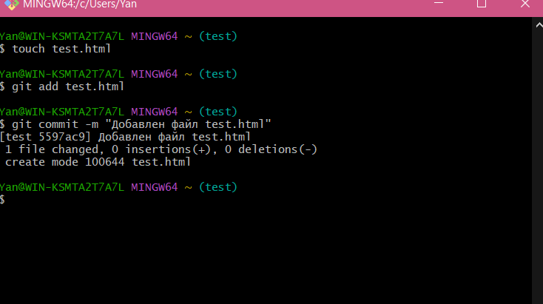nch testgit checkout test

1. Просмотрите список всех веток и определите текущую ветку.

git branch

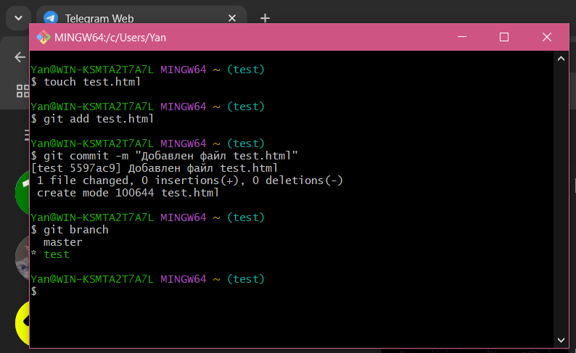

1. Выполните слияние (merge) веток.

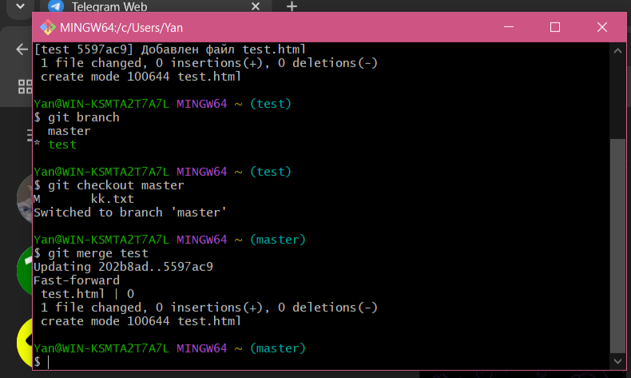

1. Выполните слияние в одной и второй ветках. Разрешите ситуацию конфликта слияний.

